1. **FA = ρ1gV1**

**F = ρ2gV2**

**FA = F**

**ρ2/ρ1 = 0,5**

**V1 = 0,5V2**

**V = πR2h − (1/2) × (4πr3/3)**

**V = πr(R − 2r2/3) = 1,3 × 10−3 м3**

2.

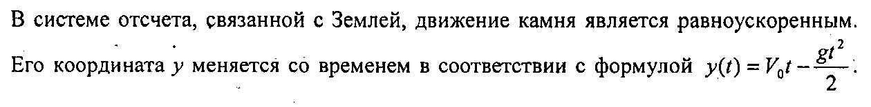

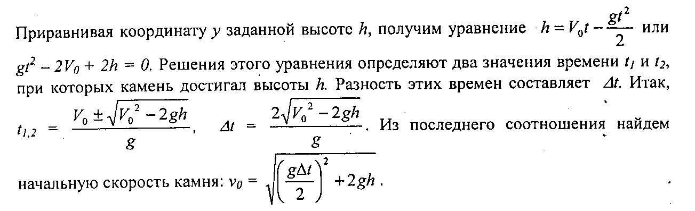

**3)** 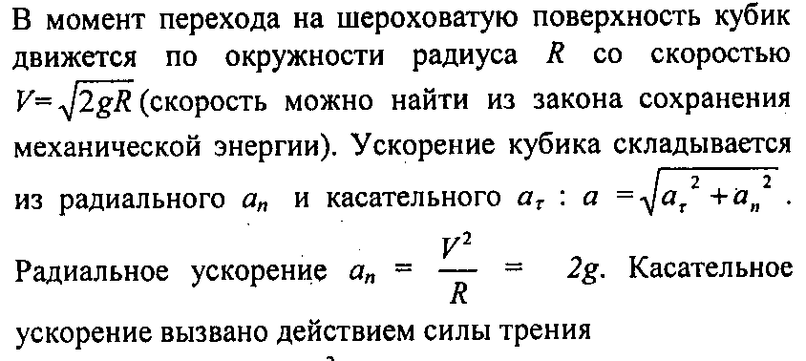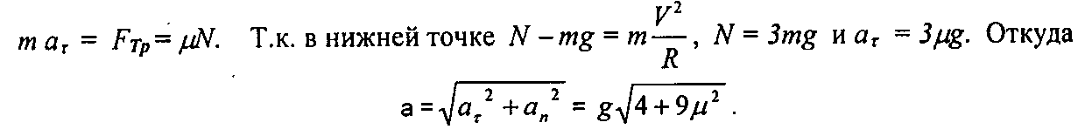

**4)** 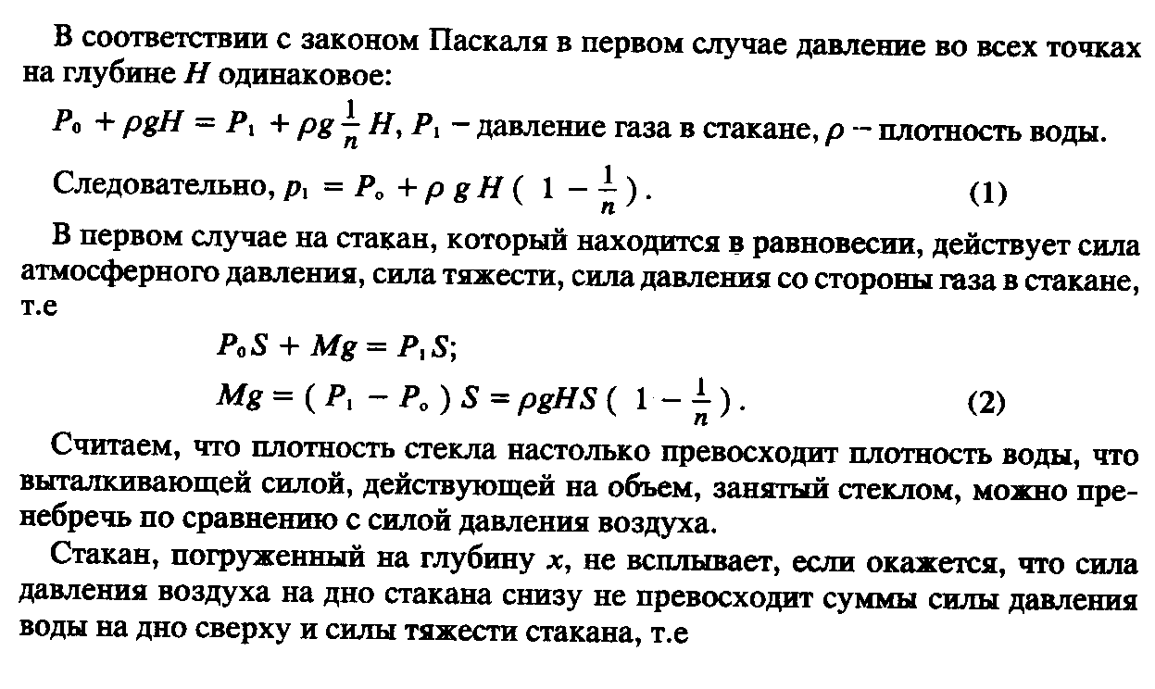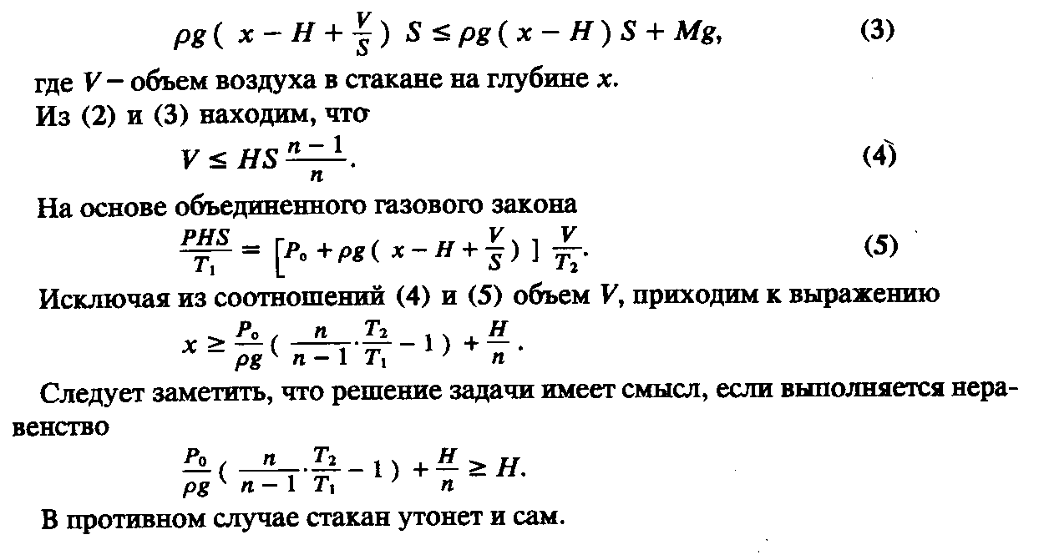

**5)**  http://www.alsak.ru/images/stories/magazine/kvant/1979/aslamaz-79-10/image046.gif